
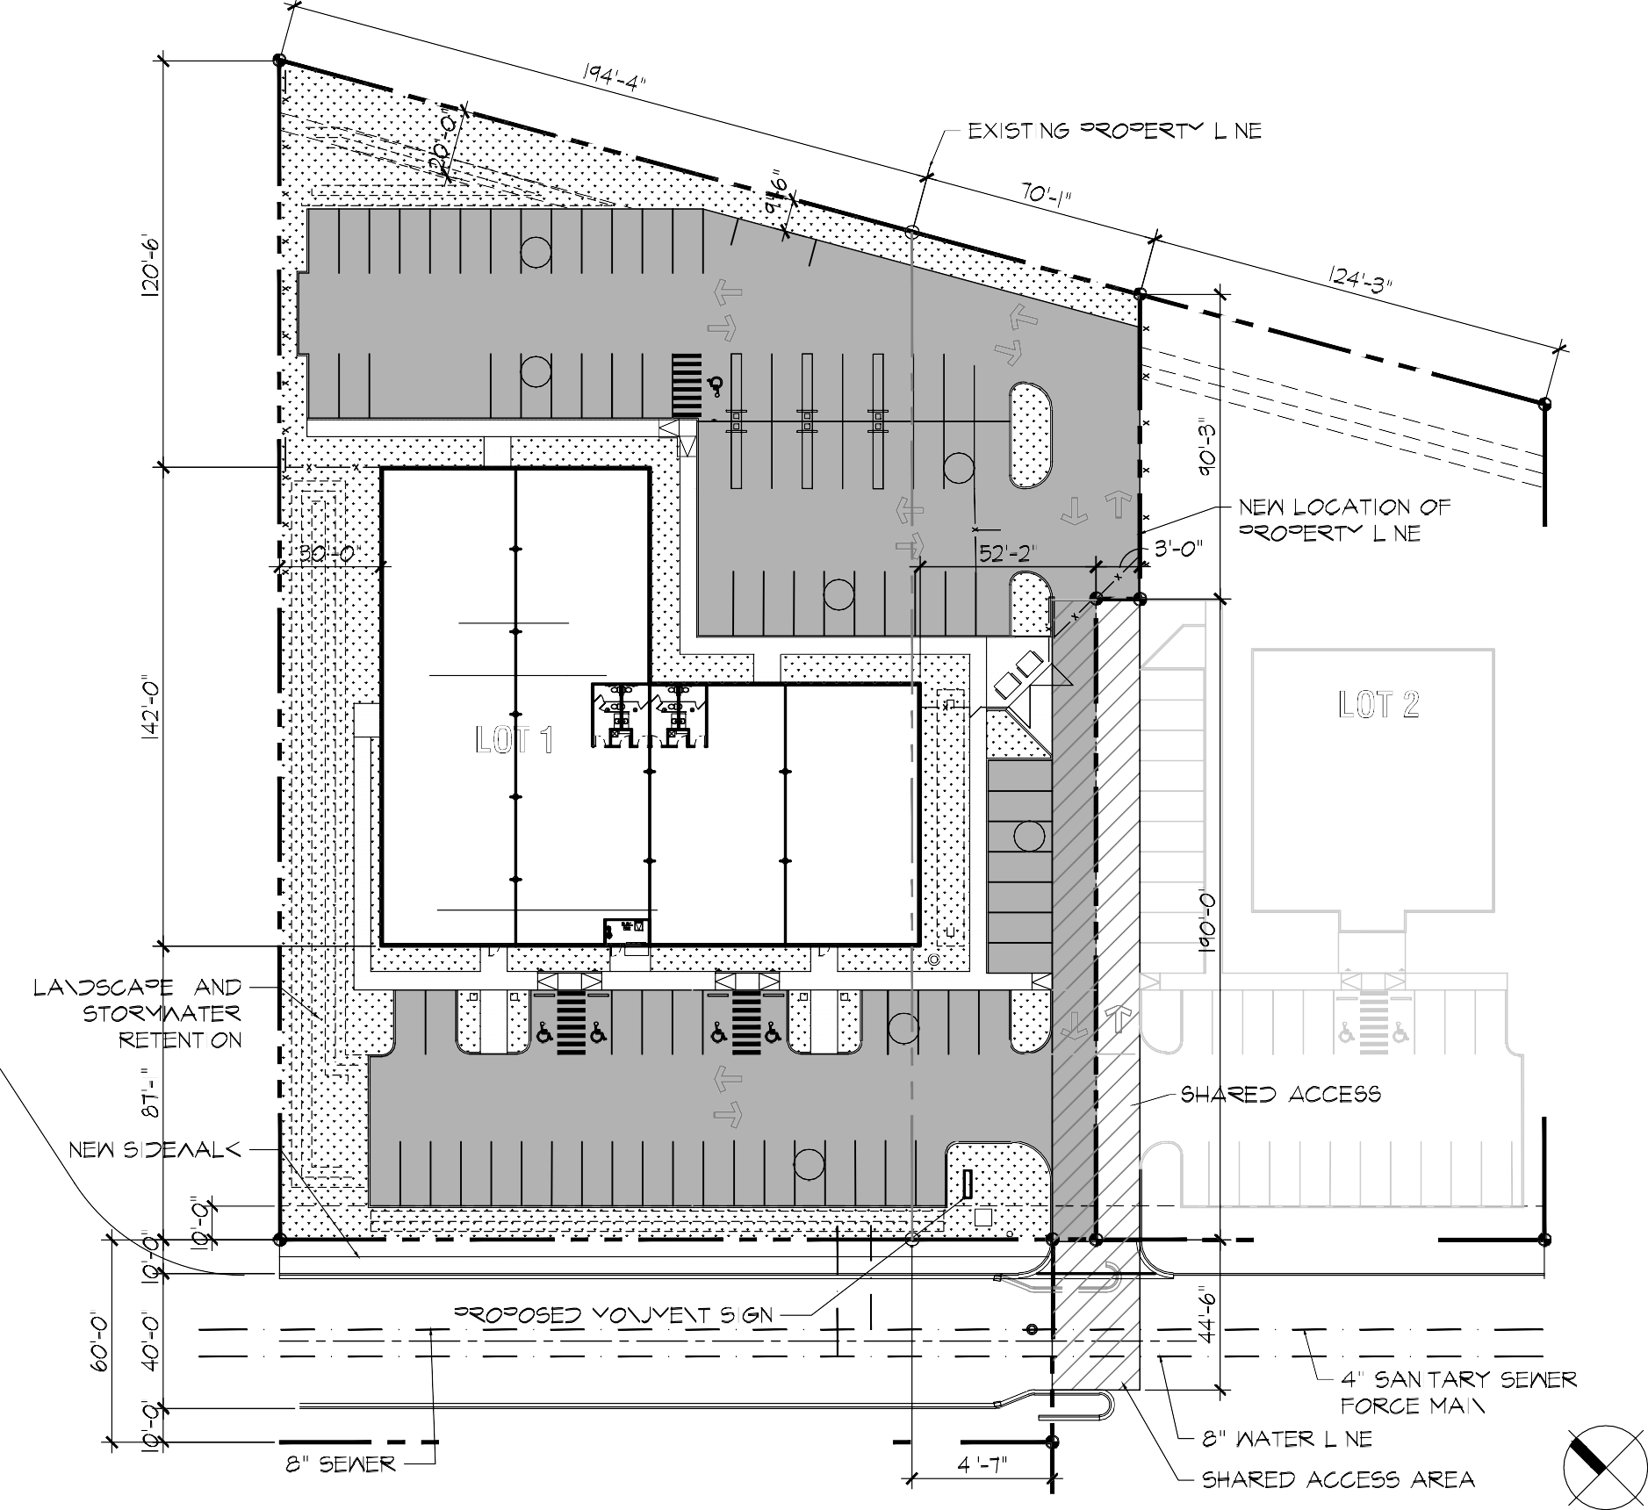
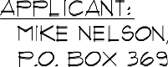
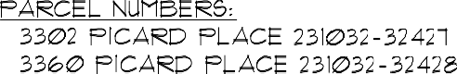
PROJECT NOTES:
1
53 STALLS
2
EV EV EV EV EV EV
C
M
EV EV EV EV EV EV
11,360 SF
80'd x 142'
9
NEW BLD'G 1
10
6,240 SF
78'x80'd
17,600 SF 220'x80'd
Code 1 per 200 sf = REQUIRED = 89 parking stalls PROVIDE = 94 parking stalls
LOT 1
77,875 SF / 1.788 ACRES
FUTURE
NEW LOT SIZE 34,138 SF / 0.784 ACRES
7
FLAG POLE
EC EC
14
40 STALLS
93 TOTAL STALLS
187.55' S 57d 54' 38" E
187.55' S 57d 54' 38" E
S
W
S
S
S
S
W
W
W
W
229.16' S 57d 54' 38" E
N
SITE PLAN
19
4
0
EXISTING 6' CHAINLINK FENCE
194.34' N 42d 42' 32" W
194.34' N 42d 42' 32" W
EXISTING CHAINLINK FENCE

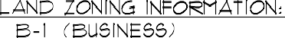
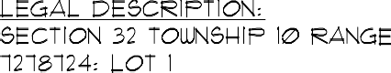

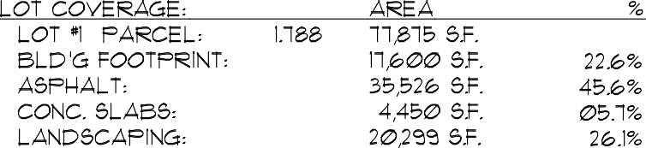
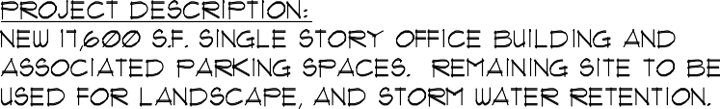

SITE / BUILDING INFO:
349.51'
N 32d 05'22" E
298.61'
N 32d 05'22" E
DUMPSTERS
247.70'
N 32d 05'22" E

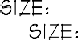

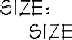

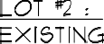
SCALE: 1" = 50' - 0"
11/2/2023 4:12:28 PM
60.00'

New Building for:

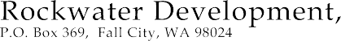

10702 ESTES ROAD YAKIMA, WA 98908 T: 509. 961. 7404 E: DON @ POSTONARCHITECTS.COM

PA NO: FILE: DATE: SHEET:

2318

Sunnyside Site Master.dwg
11. 02. 23

A.01

SEPA1 Environmental Checklist

Purpose of checklist
Governmental agencies use this checklist to help determine whether the environmental impacts of your proposal are significant. This information is also helpful to determine if available avoidance, minimization, or compensatory mitigation measures will address the probable significant impacts or if an environmental impact statement will be prepared to further analyze the proposal.

Instructions for applicants
This environmental checklist asks you to describe some basic information about your proposal. Please answer each question accurately and carefully, to the best of your knowledge. You may need to consult with an agency specialist or private consultant for some questions. You may use “not applicable” or “does not apply” only when you can explain why it does not apply and not when the answer is unknown. You may also attach or incorporate by reference additional studies reports. Complete and accurate answers to these questions often avoid delays with the SEPA process as well as later in the decision-making process.
The checklist questions apply to all parts of your proposal, even if you plan to do them over a period of time or on different parcels of land. Attach any additional information that will help describe your proposal or its environmental effects. The agency to which you submit this checklist may ask you to explain your answers or provide additional information reasonably related to determining if there may be significant adverse impact.

Instructions for lead agencies
Please adjust the format of this template as needed. Additional information may be necessary to evaluate the existing environment, all interrelated aspects of the proposal and an analysis of adverse impacts. The checklist is considered the first but not necessarily the only source of information needed to make an adequate threshold determination. Once a threshold determination is made, the lead agency is responsible for the completeness and accuracy of the checklist and other supporting documents.

Use of checklist for nonproject proposals
For nonproject proposals (such as ordinances, regulations, plans and programs), complete the applicable parts of sections A and B, plus the Supplemental Sheet for Nonproject Actions (Part D). Please completely answer all questions that apply and note that the words "project," "applicant," and "property or site" should be read as "proposal," "proponent," and "affected geographic area," respectively. The lead agency may exclude (for non- projects) questions in “Part B: Environmental Elements” that do not contribute meaningfully to the analysis of the proposal.

¹ https://ecology.wa.gov/Regulations-Permits/SEPA/Environmental-review/SEPA-guidance/Checklist-guidance
SEPA Environmental checklist September 2023 Page 1

Background
Find help answering background questions²
  - Name of proposed project, if applicable:
Picard Place Office
  - Name of applicant:
Michael Nelson
  - Address and phone number of applicant and contact person:
P.O. Box 369 Fall City, WA 98024 425-269-3331 Michael Nelson
  - Date checklist prepared:
11/6/23
  - Agency requesting checklist:
City of Sunnyside
  - Proposed timing of schedule (including phasing, if applicable):
11/15/23 – 12/15/23 Permitting 1/1/24 -6/30/24 Construction
  - Do you have any plans for future additions, expansion, or further activity related to or connected with this proposal? If yes, explain.
No future additions, expansion or activity planned.
  - List any environmental information you know about that has been prepared, or will be prepared, directly related to this proposal.
Phase 1 environmental site assessment will be prepared
  - Do you know whether applications are pending for governmental approvals of other proposals directly affecting the property covered by your proposal? If yes, explain.
Yes, a boundary line adjustment will be necessary.
  - List any government approvals or permits that will be needed for your proposal, if known.
Building Permit, Public Works Permit, Plumbing, HVAC and Electrical Permits
  - Give brief, complete description of your proposal, including the proposed uses and the size of the project and site. There are several questions later in this checklist that ask you to describe certain aspects of your proposal. You do not need to repeat those answers on this page. (Lead agencies may modify this form to include additional specific information on project description.)
Construction of an approximately 18,000 SF office building, code required parking, site and street improvements as required.

² https://ecology.wa.gov/Regulations-Permits/SEPA/Environmental-review/SEPA-guidance/SEPA-checklist- guidance/SEPA-Checklist-Section-A-Background

  - Location of the proposal. Give sufficient information for a person to understand the precise location of your proposed project, including a street address, if any, and section, township, and range, if known. If a proposal would occur over a range of area, provide the range or boundaries of the site(s). Provide a legal description, site plan, vicinity map, and topographic map, if reasonably available. While you should submit any plans required by the agency, you are not required to duplicate maps or detailed plans submitted with any permit applications related to this checklist.
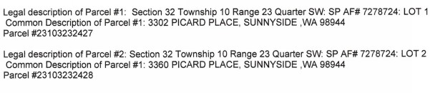

Environmental Elements

Earth
Find help answering earth questions³
    - General description of the site:

Circle or highlight one: Flat, rolling, hilly, steep slopes, mountainous, other:

    - What is the steepest slope on the site (approximate percent slope)?
Less than 2%
    - What general types of soils are found on the site (for example, clay, sand, gravel, peat, muck)? If you know the classification of agricultural soils, specify them, and note any agricultural land of long-term commercial significance and whether the proposal results in removing any of these soils.
Cleman Very Fine Sandy Loam and Esquatzel Silt Loam
    - Are there surface indications or history of unstable soils in the immediate vicinity? If so, describe.
No
    - Describe the purpose, type, total area, and approximate quantities and total affected area of any filling, excavation, and grading proposed. Indicate source of fill.

³ https://ecology.wa.gov/regulations-permits/sepa/environmental-review/sepa-guidance/sepa-checklist- guidance/sepa-checklist-section-b-environmental-elements/environmental-elements-earth

77,000 SF of disturbed soil area during development process. Plans are to use onsite soils for any grading necessary to drain water away from building. Top soils and sod will be kept onsite for landscaping. No offsite fill is expected, gravel for base course will be locally sourced.
    - Could erosion occur because of clearing, construction, or use? If so, generally describe.
TESC measures will be used and BMPs to combat any potential for erosion. Sheet erosion and wind erosion are possibilities during construction but will be mitigated by best management practices of onsite CECSL
    - About what percent of the site will be covered with impervious surfaces after project construction (for example, asphalt or buildings)?
72%
    - Proposed measures to reduce or control erosion, or other impacts to the earth, if any.
Proposal will meet County required clearing and grading regulations. TESC measures will be used during construction. We will have certified erosion control and sediment lead on site as well as erosion control plan as part of permit. Watering and covering of exposed soils to eliminate wind and rain erosion. Also, construction entrances and silt fencing will be used as need ed to contain all sediment on site. Any track out will be either swept by hand or through a commercial sweeping service.

Air
Find help answering air questions⁴
    - What types of emissions to the air would result from the proposal during construction, operation, and maintenance when the project is completed? If any, generally describe and give approximate quantities if known.
Emissions to the air from earthwork equipment for the first two months of construction after which site emissions would come from commuting construction works and eventually tenants and clients.
    - Are there any off-site sources of emissions or odor that may affect your proposal? If so, generally describe.
No.
    - Proposed measures to reduce or control emissions or other impacts to air, if any:
The use of new heavy equipment meeting current emissions standards. Carpooling where possible will be encouraged for construction workers. All tools, equipment and construction machinery will be maintained in good working order. Open dirt areas used for vehicle circulation on site will be wet down during dry weather to minimize dust.

⁴ https://ecology.wa.gov/Regulations-Permits/SEPA/Environmental-review/SEPA-guidance/SEPA-checklist- guidance/SEPA-Checklist-Section-B-Environmental-elements/Environmental-elements-Air

Water
Find help answering water questions⁵
    - Surface:
Find help answering surface water questions⁶
      - Is there any surface water body on or in the immediate vicinity of the site (including year-round and seasonal streams, saltwater, lakes, ponds, wetlands)? If yes, describe type and provide names. If appropriate, state what stream or river it flows into.
No
      - Will the project require any work over, in, or adjacent to (within 200 feet) the described waters? If yes, please describe and attach available plans.
N/A
      - Estimate the amount of fill and dredge material that would be placed in or removed from surface water or wetlands and indicate the area of the site that would be affected. Indicate the source of fill material.
N/A
      - Will the proposal require surface water withdrawals or diversions? Give a general description, purpose, and approximate quantities if known.
No
      - Does the proposal lie within a 100-year floodplain? If so, note location on the site plan.
No
      - Does the proposal involve any discharges of waste materials to surface waters? If so, describe the type of waste and anticipated volume of discharge.
No
    - Ground:
Find help answering ground water questions⁷
      - Will groundwater be withdrawn from a well for drinking water or other purposes? If so, give a general description of the well, proposed uses and approximate quantities withdrawn from the well. Will water be discharged to groundwater? Give a general description, purpose, and approximate quantities if known.

⁵ https://ecology.wa.gov/Regulations-Permits/SEPA/Environmental-review/SEPA-guidance/SEPA-checklist- guidance/SEPA-Checklist-Section-B-Environmental-elements/Environmental-elements-3-Water
⁶ https://ecology.wa.gov/Regulations-Permits/SEPA/Environmental-review/SEPA-guidance/SEPA-checklist- guidance/SEPA-Checklist-Section-B-Environmental-elements/Environmental-elements-3-Water/Environmental- elements-Surface-water
⁷ https://ecology.wa.gov/Regulations-Permits/SEPA/Environmental-review/SEPA-guidance/SEPA-checklist- guidance/SEPA-Checklist-Section-B-Environmental-elements/Environmental-elements-3-Water/Environmental- elements-Groundwater

No
      - Describe waste material that will be discharged into the ground from septic tanks or other sources, if any (domestic sewage; industrial, containing the following chemicals…; agricultural; etc.). Describe the general size of the system, the number of such systems, the number of houses to be served (if applicable), or the number of animals or humans the system(s) are expected to serve.
None
    - Water Runoff (including stormwater):
      - Describe the source of runoff (including storm water) and method of collection and disposal, if any (include quantities, if known). Where will this water flow? Will this water flow into other waters? If so, describe.
The primary source of runoff will be from stormwater. During construction there will be the potential for runoff but this will be managed by BMPs identified in the Temporary Erosion and Sediment Control Plan. After construction the project will have stormwater runoff from the parking lots, roofs, sidewalks, driveways and landscape areas. Runoff will be collected and conveyed through an onsite stormwater flow control and treatment system that complies with applicable County and State regulations before being discharged into surface swales.
      - Could waste materials enter ground or surface waters? If so, generally describe.
No, the only waste material will come from vehicles and water carrying that material. Runoff will go through treatment prior to infiltration.
      - Does the proposal alter or otherwise affect drainage patterns in the vicinity of the site? If so, describe.
No
    - Proposed measures to reduce or control surface, ground, and runoff water, and drainage pattern impacts, if any:
Project will be designed to meet current surface water regulations.

Plants
Find help answering plants questions
    - Check the types of vegetation found on the site:
- deciduous tree: alder, maple, aspen, other
- evergreen tree: fir, cedar, pine, other
- shrubs
☒ grass
- pasture
- crop or grain

- orchards, vineyards, or other permanent crops.
- wet soil plants: cattail, buttercup, bullrush, skunk cabbage, other
- water plants: water lily, eelgrass, milfoil, other
- other types of vegetation
    - What kind and amount of vegetation will be removed or altered?
All existing vegetation will be removed from the site
    - List threatened and endangered species known to be on or near the site.
None
    - Proposed landscaping, use of native plants, or other measures to preserve or enhance vegetation on the site, if any.
Landscape will be designed to comply with City standards
    - List all noxious weeds and invasive species known to be on or near the site.
None observed, Dept of Agriculture does place this portion of Sunnyside in the quarantine area for Japanese Beetle

Animals
Find help answering animal questions⁸
    - List any birds and other animals that have been observed on or near the site or are known to be on or near the site.
Examples include:
- Birds: hawk, heron, eagle, songbirds, other:
- Mammals: deer, bear, elk, beaver, other:
- Fish: bass, salmon, trout, herring, shellfish, other:
No birds or animals were observed at the site.
    - List any threatened and endangered species known to be on or near the site.
None observed, IPaC from the U.S. Fish and Wildlife Service indicates there are no critical habitats at the site location.
    - Is the site part of a migration route? If so, explain.
Yes, the Pacific Flyway
    - Proposed measures to preserve or enhance wildlife, if any.
Native plants will be used in landscaping.

⁸ https://ecology.wa.gov/Regulations-Permits/SEPA/Environmental-review/SEPA-guidance/SEPA-checklist- guidance/SEPA-Checklist-Section-B-Environmental-elements/Environmental-elements-5-Animals

    - List any invasive animal species known to be on or near the site.
None known

Energy and natural resources
Find help answering energy and natural resource questions⁹
    - What kinds of energy (electric, natural gas, oil, wood stove, solar) will be used to meet the completed project's energy needs? Describe whether it will be used for heating, manufacturing, etc.
Electricity for heating, hot water, appliances and lighting.
    - Would your project affect the potential use of solar energy by adjacent properties? If so, generally describe.
No
    - What kinds of energy conservation features are included in the plans of this proposal? List other proposed measures to reduce or control energy impacts, if any.
The project will be designed to meet all applicable energy code requirements.

Environmental health
Health Find help with answering environmental health questions¹⁰
    - Are there any environmental health hazards, including exposure to toxic chemicals, risk of fire and explosion, spill, or hazardous waste, that could occur because of this proposal? If so, describe. During construction there is a limited risk of fire associated with equipment and vehicles. The building will be designed to meet fire code requirements

      - Describe any known or possible contamination at the site from present or past uses.
None is known, Phase 1 environmental study will be performed.
      - Describe existing hazardous chemicals/conditions that might affect project development and design. This includes underground hazardous liquid and gas transmission pipelines located within the project area and in the vicinity.
None known, locate services will be required to identify any transmission pipelines.
      - Describe any toxic or hazardous chemicals that might be stored, used, or produced during the project's development or construction, or at any time during the operating life of the project.

⁹ https://ecology.wa.gov/Regulations-Permits/SEPA/Environmental-review/SEPA-guidance/SEPA-checklist- guidance/SEPA-Checklist-Section-B-Environmental-elements/Environmental-elements-6-Energy-natural-resou ¹⁰ https://ecology.wa.gov/Regulations-Permits/SEPA/Environmental-review/SEPA-guidance/SEPA-checklist- guidance/SEPA-Checklist-Section-B-Environmental-elements/Environmental-elements-7-Environmental-health

Some finish products such as paint are hazardous before they are cured, care will taken to ensure no spills happen and proper storage practices are observed.
      - Describe special emergency services that might be required.
Possible aid services may be needed by tenants or clients.
      - Proposed measures to reduce or control environmental health hazards, if any.
The project will be constructed in accordance with OSHA regulations. The proposed occupancy is not prone to producing environmental health hazards
    - Noise
      - What types of noise exist in the area which may affect your project (for example: traffic, equipment, operation, other)?
Typical vehicle traffic noise.
      - What types and levels of noise would be created by or associated with the project on a short-term or a long-term basis (for example: traffic, construction, operation, other)? Indicate what hours noise would come from the site)?
Short term: Associated noise from construction activities during allowed construction hours. Long term: low speed traffic noise typical of existing surrounding development
      - Proposed measures to reduce or control noise impacts, if any:
Perform construction during normal working hours established by County/City. Any noise generated will comply with County/City noise standards per applicable code.

Land and shoreline use
Find help answering land and shoreline use questions¹¹
    - What is the current use of the site and adjacent properties? Will the proposal affect current land uses on nearby or adjacent properties? If so, describe.
Current use of the site is vacant land. The proposed use is compatible with adjacent uses and will enhance the area.
    - Has the project site been used as working farmlands or working forest lands? If so, describe. How much agricultural or forest land of long-term commercial significance will be converted to other uses because of the proposal, if any? If resource lands have not been designated, how many acres in farmland or forest land tax status will be converted to nonfarm or nonforest use?
No
      - Will the proposal affect or be affected by surrounding working farm or forest land normal business operations, such as oversize equipment access, the application of pesticides, tilling, and harvesting? If so, how?

¹¹ https://ecology.wa.gov/Regulations-Permits/SEPA/Environmental-review/SEPA-guidance/SEPA-checklist- guidance/SEPA-Checklist-Section-B-Environmental-elements/Environmental-elements-8-Land-shoreline-use

No
    - Describe any structures on the site.
None existing
    - Will any structures be demolished? If so, what?
N/A
    - What is the current zoning classification of the site?
B1
    - What is the current comprehensive plan designation of the site?
Commercial
    - If applicable, what is the current shoreline master program designation of the site?
N/A
    - Has any part of the site been classified as a critical area by the city or county? If so, specify.
No
    - Approximately how many people would reside or work in the completed project?
70
    - Approximately how many people would the completed project displace?
None
    - Proposed measures to avoid or reduce displacement impacts, if any.
N/A
    - Proposed measures to ensure the proposal is compatible with existing and projected land uses and plans, if any.
The project will be designed to current land-use criteria and reviewed through the City required permit process
    - Proposed measures to reduce or control impacts to agricultural and forest lands of long-term commercial significance, if any:
N/A

Housing
Find help answering housing questions¹²
    - Approximately how many units would be provided, if any? Indicate whether high, middle, or low-income housing.

¹² https://ecology.wa.gov/Regulations-Permits/SEPA/Environmental-review/SEPA-guidance/SEPA-checklist- guidance/SEPA-Checklist-Section-B-Environmental-elements/Environmental-elements-9-Housing

N/A
    - Approximately how many units, if any, would be eliminated? Indicate whether high, middle, or low-income housing.
N/A
    - Proposed measures to reduce or control housing impacts, if any:
N/A

Aesthetics
Find help answering aesthetics questions¹³
    - What is the tallest height of any proposed structure(s), not including antennas; what is the principal exterior building material(s) proposed?
20’ Principal exterior material will be either EIFS/Stucco or Cement board siding/paneling
    - What views in the immediate vicinity would be altered or obstructed?
None
    - Proposed measures to reduce or control aesthetic impacts, if any:
The project will be designed to current city design standards

Light and glare
Find help answering light and glare questions¹⁴
    - What type of light or glare will the proposal produce? What time of day would it mainly occur?
Sources of light will include site lighting, interior building lights and automobile headlights. These will occur from dusk to dawn. Building lights will automatically shut off when unoccupied, site lighting will be shielded to reduce light pollution.
    - Could light or glare from the finished project be a safety hazard or interfere with views?
None of light sources are anticipated to be a safety hazard or to interfere with views
    - What existing off-site sources of light or glare may affect your proposal?
Street lights and automobile lights
    - Proposed measures to reduce or control light and glare impacts, if any:
All exterior light fixtures on site will be specified to be cut off type fixtures in order to prevent light from being directed upward or outward where it can create glare.

¹³ https://ecology.wa.gov/Regulations-Permits/SEPA/Environmental-review/SEPA-guidance/SEPA-checklist- guidance/SEPA-Checklist-Section-B-Environmental-elements/Environmental-elements-10-Aesthetics
¹⁴ https://ecology.wa.gov/Regulations-Permits/SEPA/Environmental-review/SEPA-guidance/SEPA-checklist- guidance/SEPA-Checklist-Section-B-Environmental-elements/Environmental-elements-11-Light-glare

Recreation
Find help answering recreation questions
    - What designated and informal recreational opportunities are in the immediate vicinity?
Grand Cinemas Yakima Valley is 300’ away, Black Rock Creek Golf Course and Sunnyview Park are 2 miles away by car
    - Would the proposed project displace any existing recreational uses? If so, describe.
No
    - Proposed measures to reduce or control impacts on recreation, including recreation opportunities to be provided by the project or applicant, if any:
None planned, project will not have impact on nearby recreation

Historic and cultural preservation
Find help answering historic and cultural preservation questions¹⁵
    - Are there any buildings, structures, or sites, located on or near the site that are over 45 years old listed in or eligible for listing in national, state, or local preservation registers? If so, specifically describe.
No
    - Are there any landmarks, features, or other evidence of Indian or historic use or occupation? This may include human burials or old cemeteries. Are there any material evidence, artifacts, or areas of cultural importance on or near the site? Please list any professional studies conducted at the site to identify such resources.
None known
    - Describe the methods used to assess the potential impacts to cultural and historic resources on or near the project site. Examples include consultation with tribes and the department of archeology and historic preservation, archaeological surveys, historic maps, GIS data, etc.
We reviewed the Washington Information System for Architectural & Archaeological Records Data (WISAARD) available online for any concerns on record and none were found
    - Proposed measures to avoid, minimize, or compensate for loss, changes to, and disturbance to resources. Please include plans for the above and any permits that may be required.
IF during work on site including excavation an artifact is found, work will be stopped and tribes contacted to make an assessment of the finds. Any finds will be categorized and saved per ordinances and rules.

¹⁵ https://ecology.wa.gov/Regulations-Permits/SEPA/Environmental-review/SEPA-guidance/SEPA-checklist- guidance/SEPA-Checklist-Section-B-Environmental-elements/Environmental-elements-13-Historic-cultural-p

Transportation
Find help with answering transportation questions¹⁶
    - Identify public streets and highways serving the site or affected geographic area and describe proposed access to the existing street system. Show on site plans, if any.
The site is served from Picard Place. Which is intern served from 241 Waneta Rd. Waneta can be accessed from SR 82 or the Yakima Valley Highway.
    - Is the site or affected geographic area currently served by public transit? If so, generally describe. If not, what is the approximate distance to the nearest transit stop?
Closest bus stop served by People for People Route 201 is 0.2 Miles away
    - Will the proposal require any new or improvements to existing roads, streets, pedestrian, bicycle, or state transportation facilities, not including driveways? If so, generally describe (indicate whether public or private).
Frontage improvements will be made per city requirements. This will include new sidewalk
    - Will the project or proposal use (or occur in the immediate vicinity of) water, rail, or air transportation? If so, generally describe.
No
    - How many vehicular trips per day would be generated by the completed project or proposal? If known, indicate when peak volumes would occur and what percentage of the volume would be trucks (such as commercial and nonpassenger vehicles). What data or transportation models were used to make these estimates?
170 Vehicular trips are anticipated. AM peak hour 30 PM peak hour 30. Of the trips 0% would be trucks. Data from Traffic study performed for recent project larger than planned, actual trips would vary and likely be less due to smaller building footprint.
    - Will the proposal interfere with, affect, or be affected by the movement of agricultural and forest products on roads or streets in the area? If so, generally describe.
No
    - Proposed measures to reduce or control transportation impacts, if any:
Bicycle rack to encourage transportation options, working with City and People to People to see if new transit stop to serve building would be possible. Paying traffic impact fees to City of Sunnyside to mitigate the roadway impacts of the development.

¹⁶ https://ecology.wa.gov/Regulations-Permits/SEPA/Environmental-review/SEPA-guidance/SEPA-checklist- guidance/SEPA-Checklist-Section-B-Environmental-elements/Environmental-elements-14-Transportation

Public services
Find help answering public service questions¹⁷
    - Would the project result in an increased need for public services (for example: fire protection, police protection, public transit, health care, schools, other)? If so, generally describe.
Public services such as fire, police health care and schools are already available within the vicinity so the project will have minimal additional impact on these services.
    - Proposed measures to reduce or control direct impacts on public services, if any.
Payment of mitigation fees as required

Utilities
Find help answering utilities questions¹⁸
    - Circle utilities currently available at the site: electricity, natural gas, water, refuse service, telephone, sanitary sewer, septic system, other:

    - Describe the utilities that are proposed for the project, the utility providing the service, and the general construction activities on the site or in the immediate vicinity which might be needed.
Water: City of Sunnyside Sanitary Sewer: City of Sunnyside Garbage; City of Sunnyside Electricity: Pacific Power

¹⁷ https://ecology.wa.gov/regulations-permits/sepa/environmental-review/sepa-guidance/sepa-checklist- guidance/sepa-checklist-section-b-environmental-elements/environmental-elements-15-public-services ¹⁸ https://ecology.wa.gov/regulations-permits/sepa/environmental-review/sepa-guidance/sepa-checklist- guidance/sepa-checklist-section-b-environmental-elements/environmental-elements-16-utilities

C.Signature
Find help about who should sign¹⁹

The above answers are true and complete to the best of my knowledge. I understand that the lead agency is relying on them to make its decision.

X
Type name of signee: Michael Nelson
Position and agency/organization: Owner, Rockwater Development LLC
Date submitted: 10/2/23

D.Supplemental sheet for nonproject actions
Find help for the nonproject actions worksheet²⁰
Do not use this section for project actions.
Because these questions are very general, it may be helpful to read them in conjunction with the list of the elements of the environment.
When answering these questions, be aware of the extent the proposal, or the types of activities likely to result from the proposal, would affect the item at a greater intensity or at a faster rate than if the proposal were not implemented. Respond briefly and in general terms.
- How would the proposal be likely to increase discharge to water; emissions to air; production, storage, or release of toxic or hazardous substances; or production of noise?
We will not increase discharge of water, electricity used by the building will increase load on local utility system but will be highly efficient and not substantial
  - Proposed measures to avoid or reduce such increases are:
Drip Irrigation system, highly efficient HVAC system, LED lighting throughout. Occupancy timers and meeting Washington state energy code.
- How would the proposal be likely to affect plants, animals, fish, or marine life?
It is not. The site is vacant arid land
  - Proposed measures to protect or conserve plants, animals, fish, or marine life are:
On site stormwater detention, native plants for landscaping, drip irrigation.
- How would the proposal be likely to deplete energy or natural resources?

¹⁹ https://ecology.wa.gov/Regulations-Permits/SEPA/Environmental-review/SEPA-guidance/SEPA-checklist- guidance/SEPA-Checklist-Section-C-Signature
²⁰ https://ecology.wa.gov/regulations-permits/sepa/environmental-review/sepa-guidance/sepa-checklist- guidance/sepa-checklist-section-d-non-project-actions

Our project will require electricity to power lighting and HVAC
  - Proposed measures to protect or conserve energy and natural resources are:
Drip Irrigation system, highly efficient HVAC system, LED lighting throughout. Occupancy timers and meeting Washington state energy code.
- How would the proposal be likely to use or affect environmentally sensitive areas or areas designated (or eligible or under study) for governmental protection, such as parks, wilderness, wild and scenic rivers, threatened or endangered species habitat, historic or cultural sites, wetlands, floodplains, or prime farmlands?
It will not.
  - Proposed measures to protect such resources or to avoid or reduce impacts are:
Not applicable, the project does not interfere with any of the aforementioned items.
- How would the proposal be likely to affect land and shoreline use, including whether it would allow or encourage land or shoreline uses incompatible with existing plans?
It will improve the existing land by eliminating invasive plants if any.
  - Proposed measures to avoid or reduce shoreline and land use impacts are:
Plant native vegetation.
- How would the proposal be likely to increase demands on transportation or public services and utilities?
Demands will be minimal but some workers and customers may opt to use public transit. Utility demands will be mitigated by meeting or exceeding Washington state energy code and efficient toilets, urinals, and lavatories.
  - Proposed measures to reduce or respond to such demand(s) are:
By meeting or exceeding Washington state energy code and efficient toilets, urinals and lavatories.
- Identify, if possible, whether the proposal may conflict with local, state, or federal laws or requirements for the protection of the environment.
The proposal will not conflict with local, state, or federal laws for the protection of the environment.


Planning & Community Development
818 East Edison Avenue Sunnyside, Washington 98944
(509) 837-7999 Office, (509) 836-6383 Fax

NOTICE OF APPLICATION & ENVIRONMENTAL REVIEW
DATE: NOVEMBER 7, 2023
TO: SEPA Reviewing Agencies, Applicant, and Adjoining Property Owners
FROM: SYDNEY DEWEES, SUNNYSIDE CITY PLANNER
APPLICANT: Michael Nelson
FILE NUMBER: SEPA-23-6
LOCATION: Vicinity of 3302 PICARD PLACE, Sunnyside WA 98944
TAX PARCEL NUMBER(S): 23103232427, 23103232428
DATE OF APPLICATION: October 2nd, 2023
DATE OF COMPLETENESS: November 6th, 2023

PROJECT DESCRIPTION Environmental Review for the proposed development of a 17,600 sq ft. office building and parking lot, in the Freeway Commercial (B-1) Zone.
NOTICE OF ENVIRONMENTAL REVIEW This is to notify agencies with jurisdiction and environmental expertise and the public that the City of Sunnyside, Planning Division, has been established as the lead agency, under WAC § 197-11-928 for this project. The City of Sunnyside has reviewed the proposed project for probable adverse environmental impacts and expects to issue a Determination of Nonsignificance (DNS) per WAC § 197-11-355. The proposal may include mitigation measures under applicable codes and the project review process may incorporate or require mitigation measures regardless of whether an EIS is prepared. A copy of the subsequent threshold determination may be obtained by request and may be appealed pursuant to SMC Ch. 18.04.

Required Permits: The following local, state, and federal permits/approvals may or will be needed for this project: Building Permit and potentially other permits suggested by DST.
Required Studies: SEPA Review, No others required at this time
Existing Environmental Documents: none
Development Regulations for Project Mitigation and Consistency Include: the State Environmental Policy Act, International Fire Code, WAC 173-180-320, WAC 296-24-33005, the Sunnyside Zoning Ordinance, SMC Title16—Subdivisions, SMC Title 12—Development Standards, and the Sunnyside Comprehensive Plan.
REQUEST FOR WRITTEN COMMENTS: Agencies, tribes, and the public are encouraged to review and comment on the proposed project and its probable environmental impacts. There is a 14-day comment period for this review. This may be your only opportunity to comment. All written comments received by 5:00 p.m. on November 29th, 2023 will be considered prior to issuing the final SEPA determination. Please reference file numbers (SEPA-23-6) and applicant’s name (Nelson) in any correspondence you submit. You can mail your comments to:

Trevor Martin, AICP, Community & Economic Development Director City of Sunnyside, Community and Economic Development Department 818 E. Edison Ave., Sunnyside, WA 98944

NOTICE OF DECISION A copy of the decision and the SEPA threshold determination will be mailed to parties of record and entities who were provided this notice once it is rendered. The file containing the complete application is available for public review at the City of Sunnyside, City Hall, 818 E. Edison Ave. If you have any questions on this proposal, please contact Sydney DeWees, City Planner. sdewees@sunntside-wa.gov.

