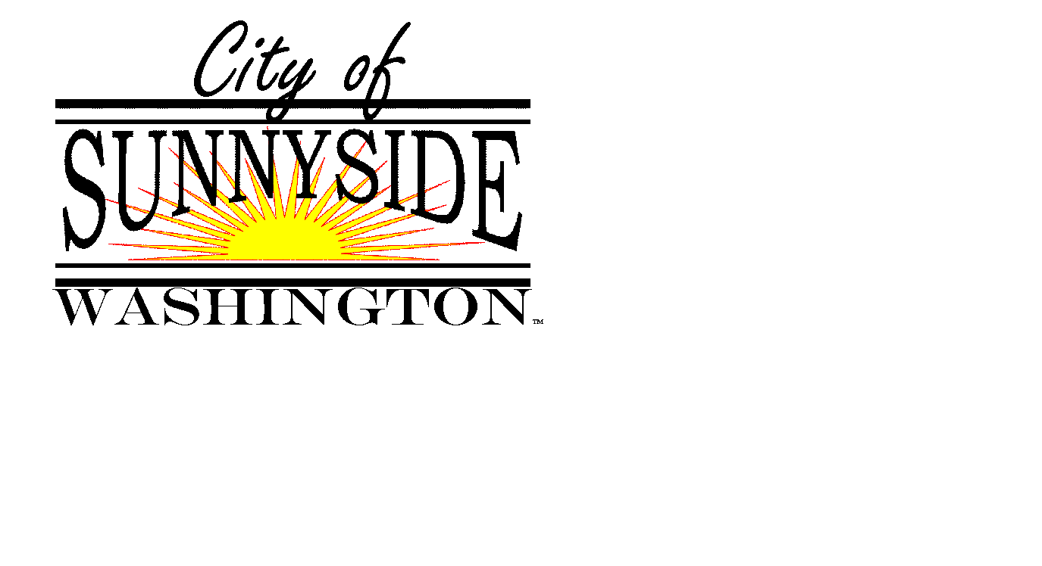
Office of the City Manager
818 East Edison Avenue
Sunnyside, Washington 98944
(509) 837-6300 Office

December 28, 2020

Media Release

Contact: City Manager Martin Casey, 509-836-6300

Sunnyside Receives Clean State Audit for 2019

Sunnyside Mayor Francisco Guerrero and City Manager Martin Casey recently met with staff from the Washington State Auditor’s Office to review the City’s annual audit for 2019.

After conducting Financial, Federal, and Accountability audits, the Auditor’s Office has issued a “clean” audit of the City, meaning there were no findings. A finding is a serious matter because it indicates significant issues concerning internal controls or the integrity of financial statements.

This marks the first time in nearly a decade that Sunnyside has received a clean audit.

Mayor Guerrero stated, “We value the State Auditor’s thorough review. Council has taken past audit findings very seriously. In 2019, we put a plan in place to increase the financial stability of the General Fund, and I appreciate that the State Auditor has recognized that effort.”

Guerrero added, “The City remains committed to strengthening our internal controls and financial practices to ensure accountability to the residents of Sunnyside.”

City Manager Casey stated, “Council and staff have worked very hard to achieve this milestone.”

Casey also recognized staff involved in the audit. “Finance Director Elizabeth Alba has been on medical leave since late September, but she guided us through the financial audit and set the stage for the remaining steps. Finance Supervisor Delilah Saenz then provided critical support to ensure the successful completion of the accountability audit.”

The public may view audit reports online at: https://sao.wa.gov/reports-data/audit-reports/

# # #

