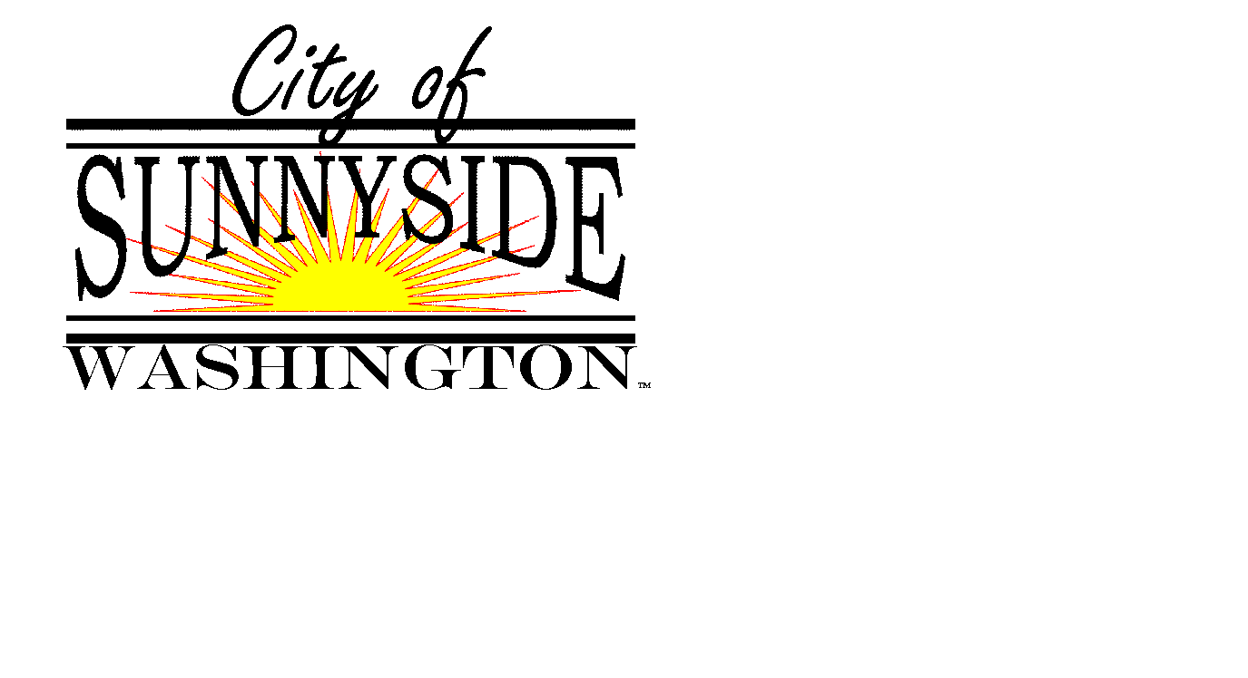
SUNNYSIDE CITY COUNCIL
SUBCOMMITTEE ON PUBLIC SAFETY
DEAN BROERSMA – JOHN HENRY – RON STREMLER

401 Homer Street, Sunnyside, Washington www.sunnyside-wa.gov

MONDAY LAW & JUSTICE CENTER
July 8, 2019, 2019 5:15 PM

ROLL CALL – CALL TO ORDER

1. ACTIVE AGENDA:

- Approve Minutes of Previous Meeting: June 10, 2019

- Police Department Reserve Officer Program Discussion

- Fire Department Volunteer Program Discussion

- Ambulance ILA Discussion

2. FUTURE AGENDA ITEMS

3. ITEMS FROM COMMITTEE MEMBERS

4. ITEMS FROM STAFF MEMBERS

5. NEXT MEETING

6. ADJOURN

