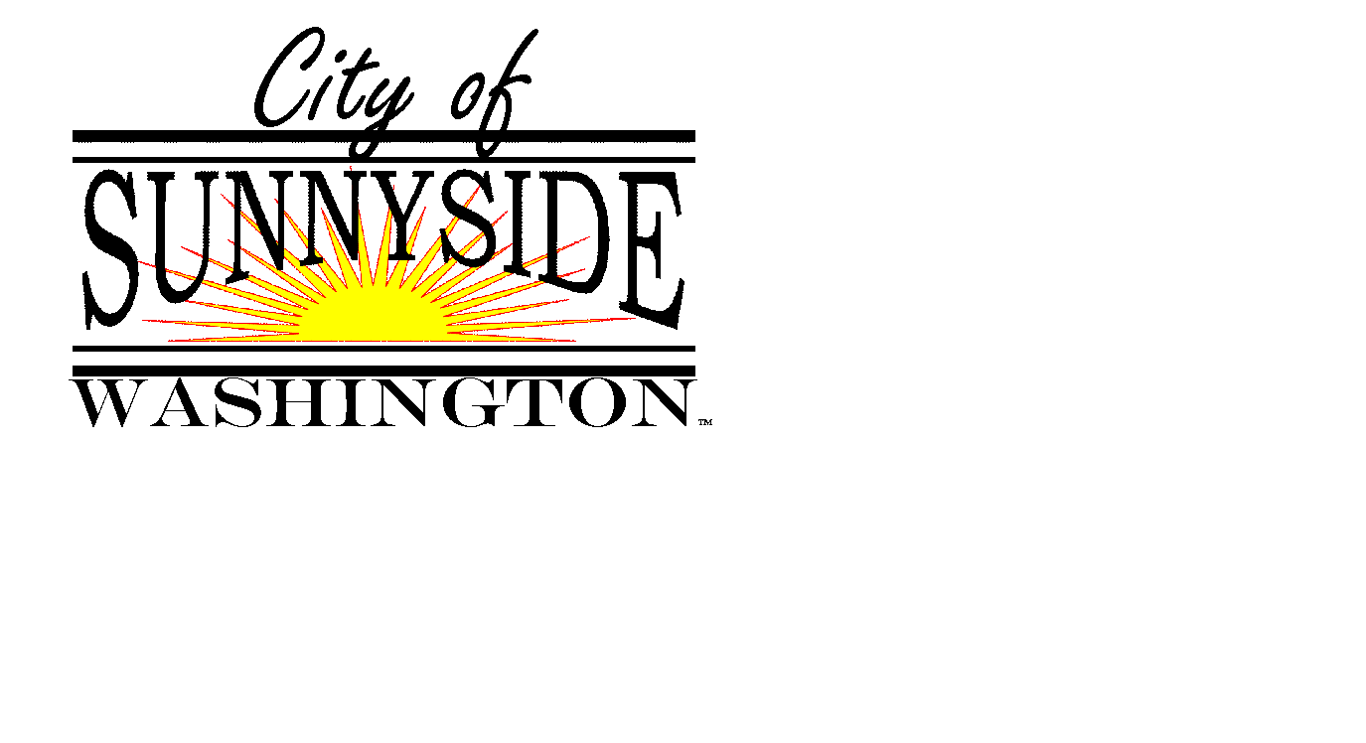
SUNNYSIDE MUNICIPAL AIRPORT
ADVISORY BOARD AGENDA
513 S. 8th Street, Sunnyside, Washington
www.sunnyside-wa.gov

TUESDAY SUNNYSIDE FIRE STATION, CONFERENCE ROOM
August 16, 2016 5:30 PM

- CALL MEETING TO ORDER

- ROLL CALL:
Larry Dolan, Chairman | Scott Stiltner
Shane Fisher, Vice Chairman | Jim Grubenhoff
Jim Restucci | Ted Durfey
Don Day | Alan Van Beek
Robert Webb

GUESTS/STAFF MEMBERS
Jacqueline Renteria, City of Sunnyside Public Works Administrative Assistant

- CONSENT AGENDA
  - Approve minutes of the July 19, 2016 Regular Meeting

- ACTIVE AGENDA
  - Airport Projects Scheduled in 2017

- ITEMS FROM COMMITTEE MEMBERS

- ITEMS FOR NEXT MEETING

- NEXT MEETING
Tuesday September 20, 2016 at 4:30 PM

- ADJOURN

