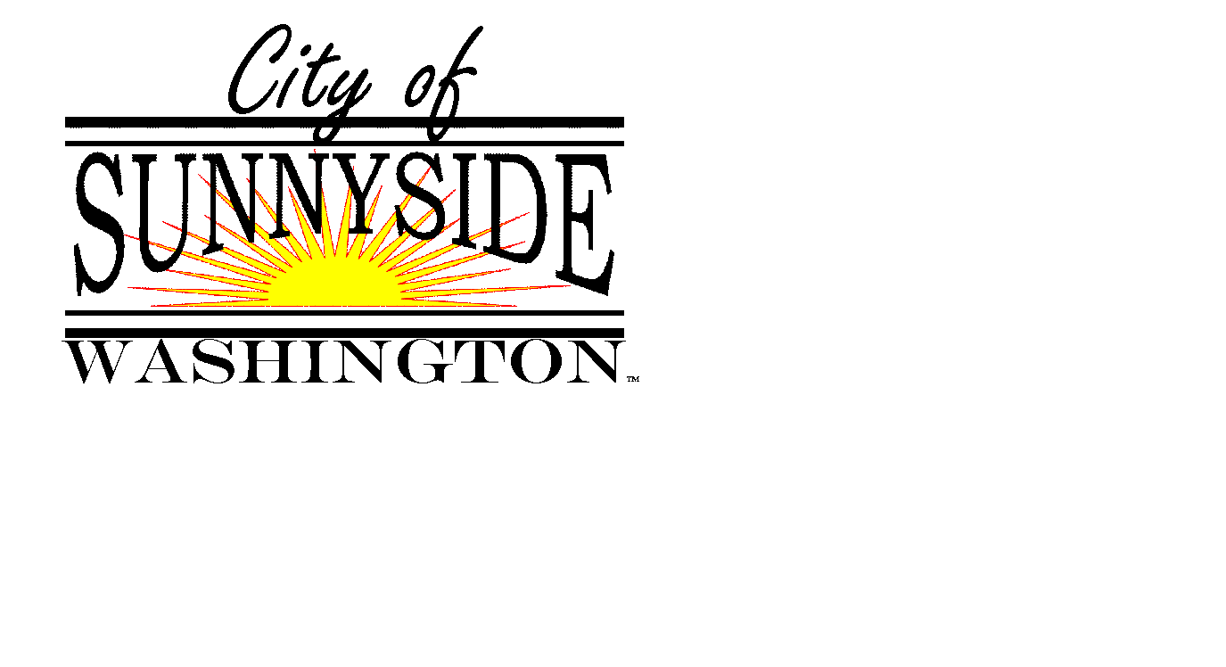
SUNNYSIDE ARTS COMMISSION

818 E. Edison Avenue, Sunnyside, Washington www.sunnyside-wa.gov

Sunnyside City Hall
Executive Conference Room
818 E Edison Avenue
Date: April 15, 2015 Time: 6:00 P.M.

CALL TO ORDER - Chairman Fannin

INTRODUCTION OF NEW COMMISSIONERS - Alyson Spidle, Loren Hancock & Dawn Haak

APPROVAL OF MINUTES - 3-12-2015 Meeting

ACTIVE AGENDA
- Challenge coin update – Restucci
- Update on Museum Art Show – Rogers, Ganser, Restucci
- Sunnyside Arts Commission vacancy (Student) - Fannin
- Sunnyside City Flower discussion- Fannin
- Discussion of commission report to City Council – Fannin

FUTURE AGENDA ITEMS
- Artists inventory
- Inventory of Art in Public Places

ITEMS FROM COMMISSION MEMBERS

CITY COUNCIL LIASON REPORT

ITEMS FROM STAFF MEMBERS

NEXT MEETING – Fix a date and time for the next meeting

