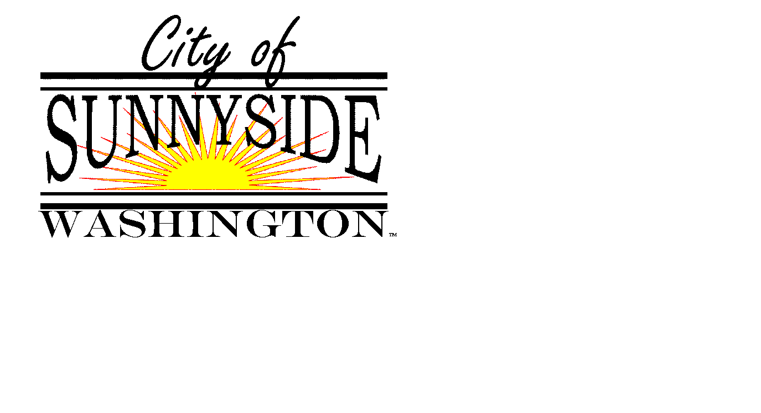
SUNNYSIDE ARTS COMMISSION

818 E. Edison Avenue, Sunnyside, Washington www.sunnyside-wa.gov

Sunnyside City Hall
Executive Conference Room
818 E Edison Avenue
Date: May 20, 2015 Time: 6:00 P.M.

CALL TO ORDER - Chairman Fannin

APPROVAL OF MINUTES – 4-15-2015

ACTIVE AGENDA
- Artist Inventory & Art in Public Places – Day, City Manager
- City e-mail use – Fannin
- Art Show Sub-committee report – Rogers, Chair, Haak, Vice Chair, Mendoza, Ganser
- Alpaca Farm Art Show – Ganser
- Art Commission Vacancy – Fannin
- Commission Report to Council – Work group –Restucci, Mendoza

FUTURE agenda items
- Sunnyside City Flower – Tabled until June

ITEMS FROM COMMISSION MEMBERS

CITY COUNCIL LIASON REPORT

ITEMS FROM STAFF MEMBERS

NEXT MEETING – Fix a date and time for the next meeting

